BA02A- Baby Shower Craft Love Cute Scrapbook FORM FOR TEXT

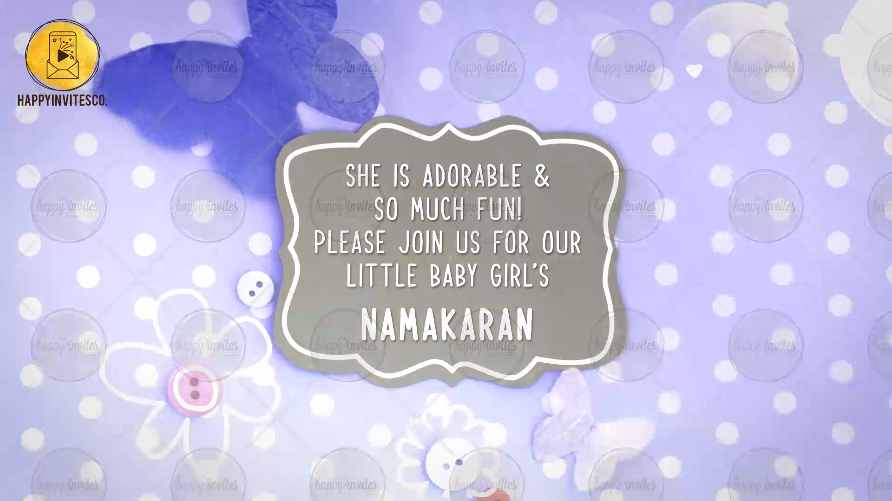
SLIDE 1:
Line 1: She is adorable & so much fun!
Please join us for our Little Baby Girl’s NAMAKARAN

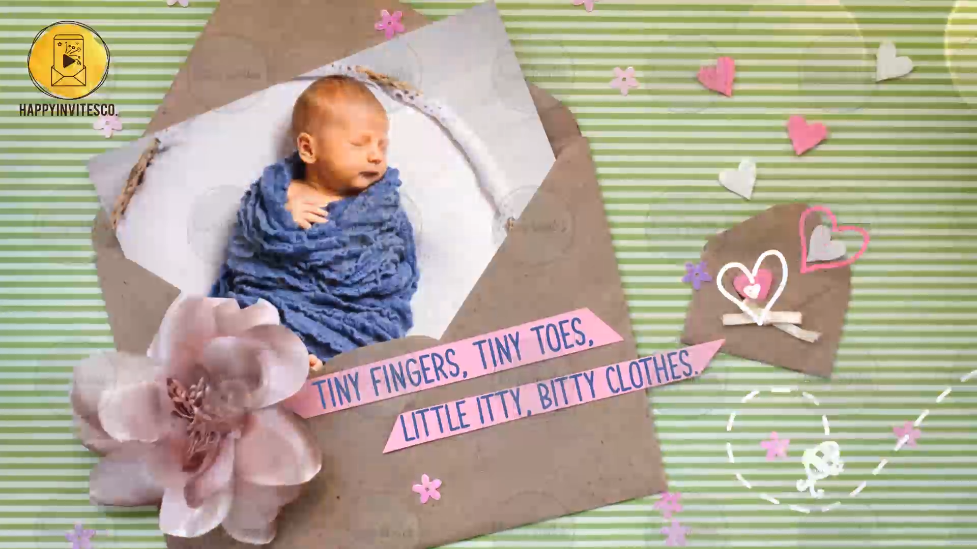
SLIDE 2:
Tiny fingers, tiny toes,
Little itty, bittly clothes.

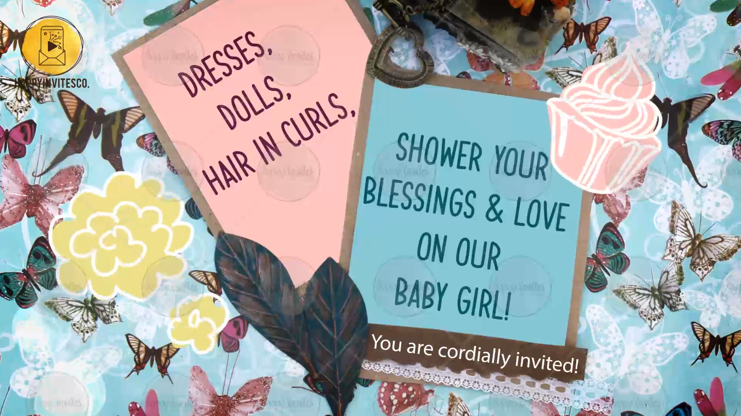
SLIDE 3:
Line 1: Dresses, dolls, hair in curls,
Line 2: Shower your blessings & love on our Baby Girl!
Line 3: You are cordially invited!

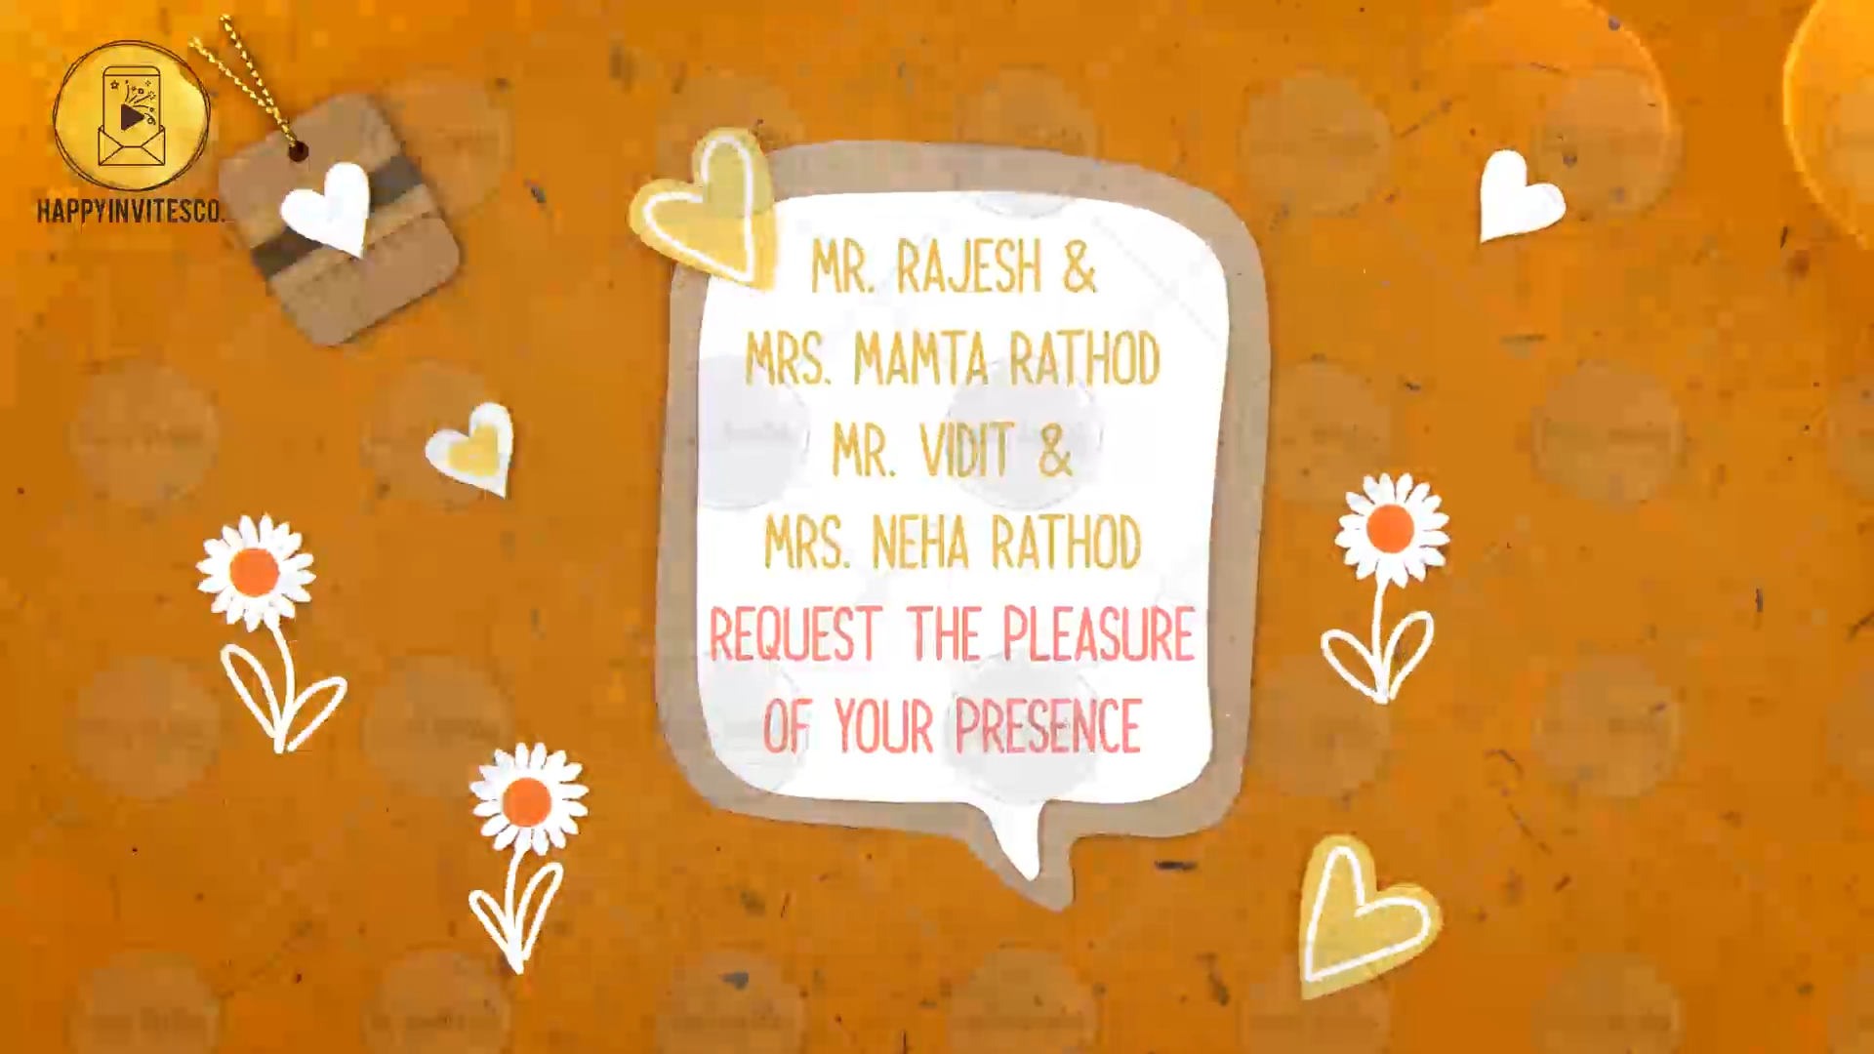
SLIDE 4:
Grandparents Names:
Parents Names:
Request the pleasure of your presence

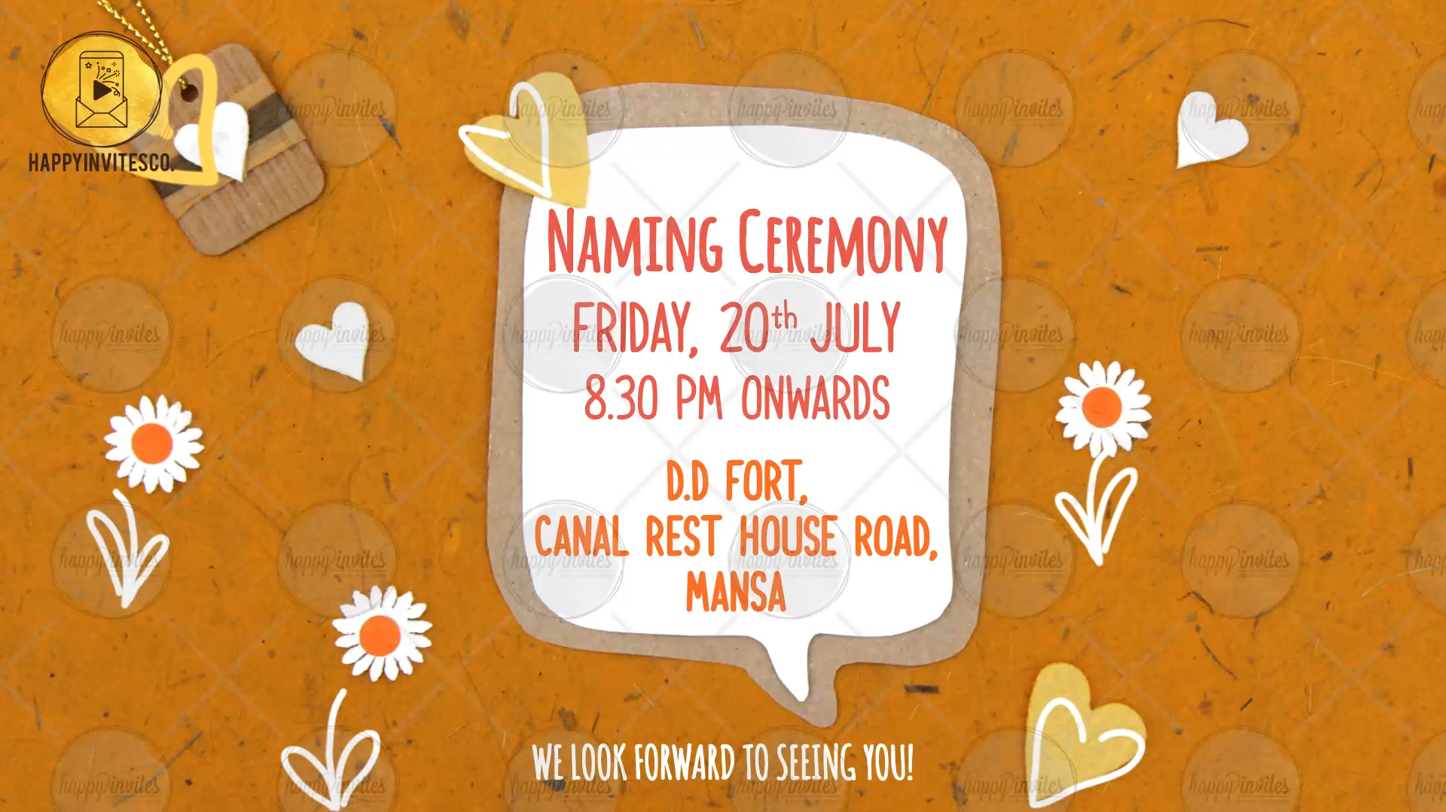
SLIDE 5:
Title of the Function:
Date of the function:
Time of the function:
Venue of the Function:

With best wishes,
Please mention the names of family members or family surnames

