BA02A- Baby Shower Craft Love Cute Scrapbook FORM FOR TEXT

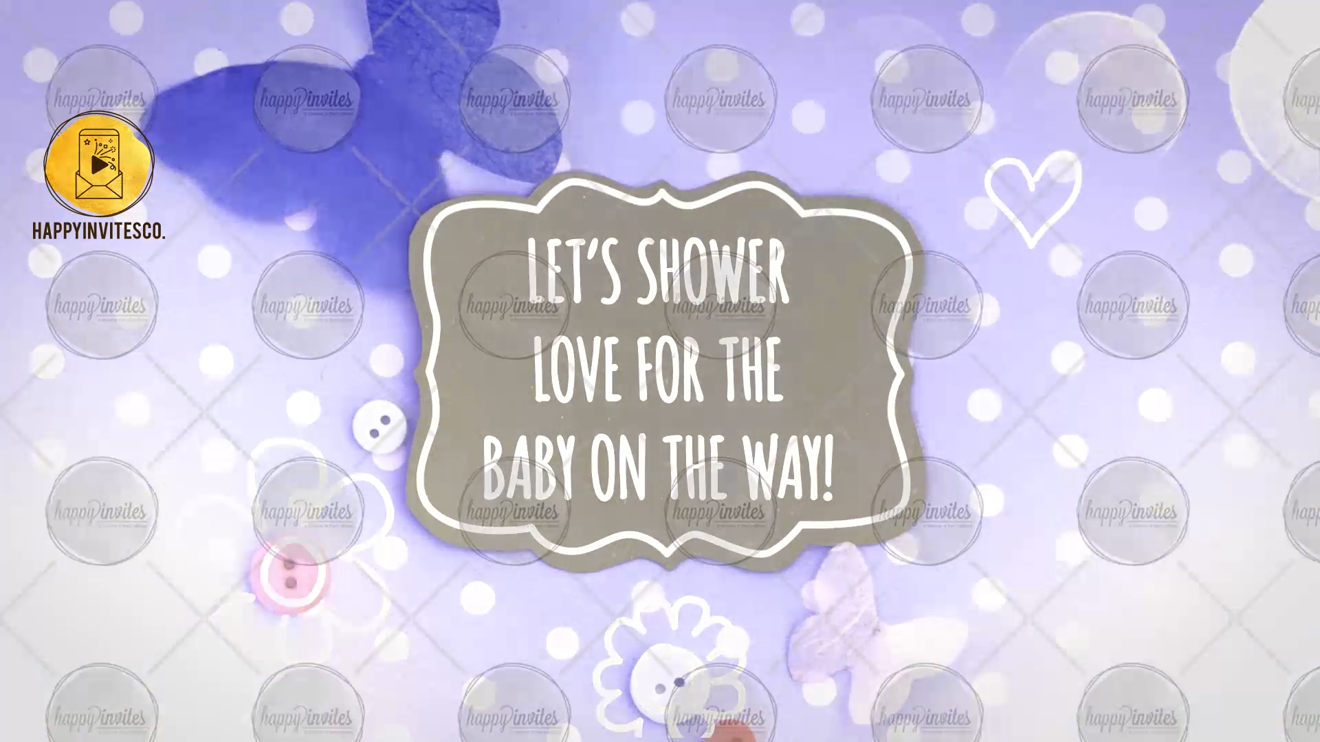
SLIDE 1:
Line 1: Let’s shower love for the baby on the way!

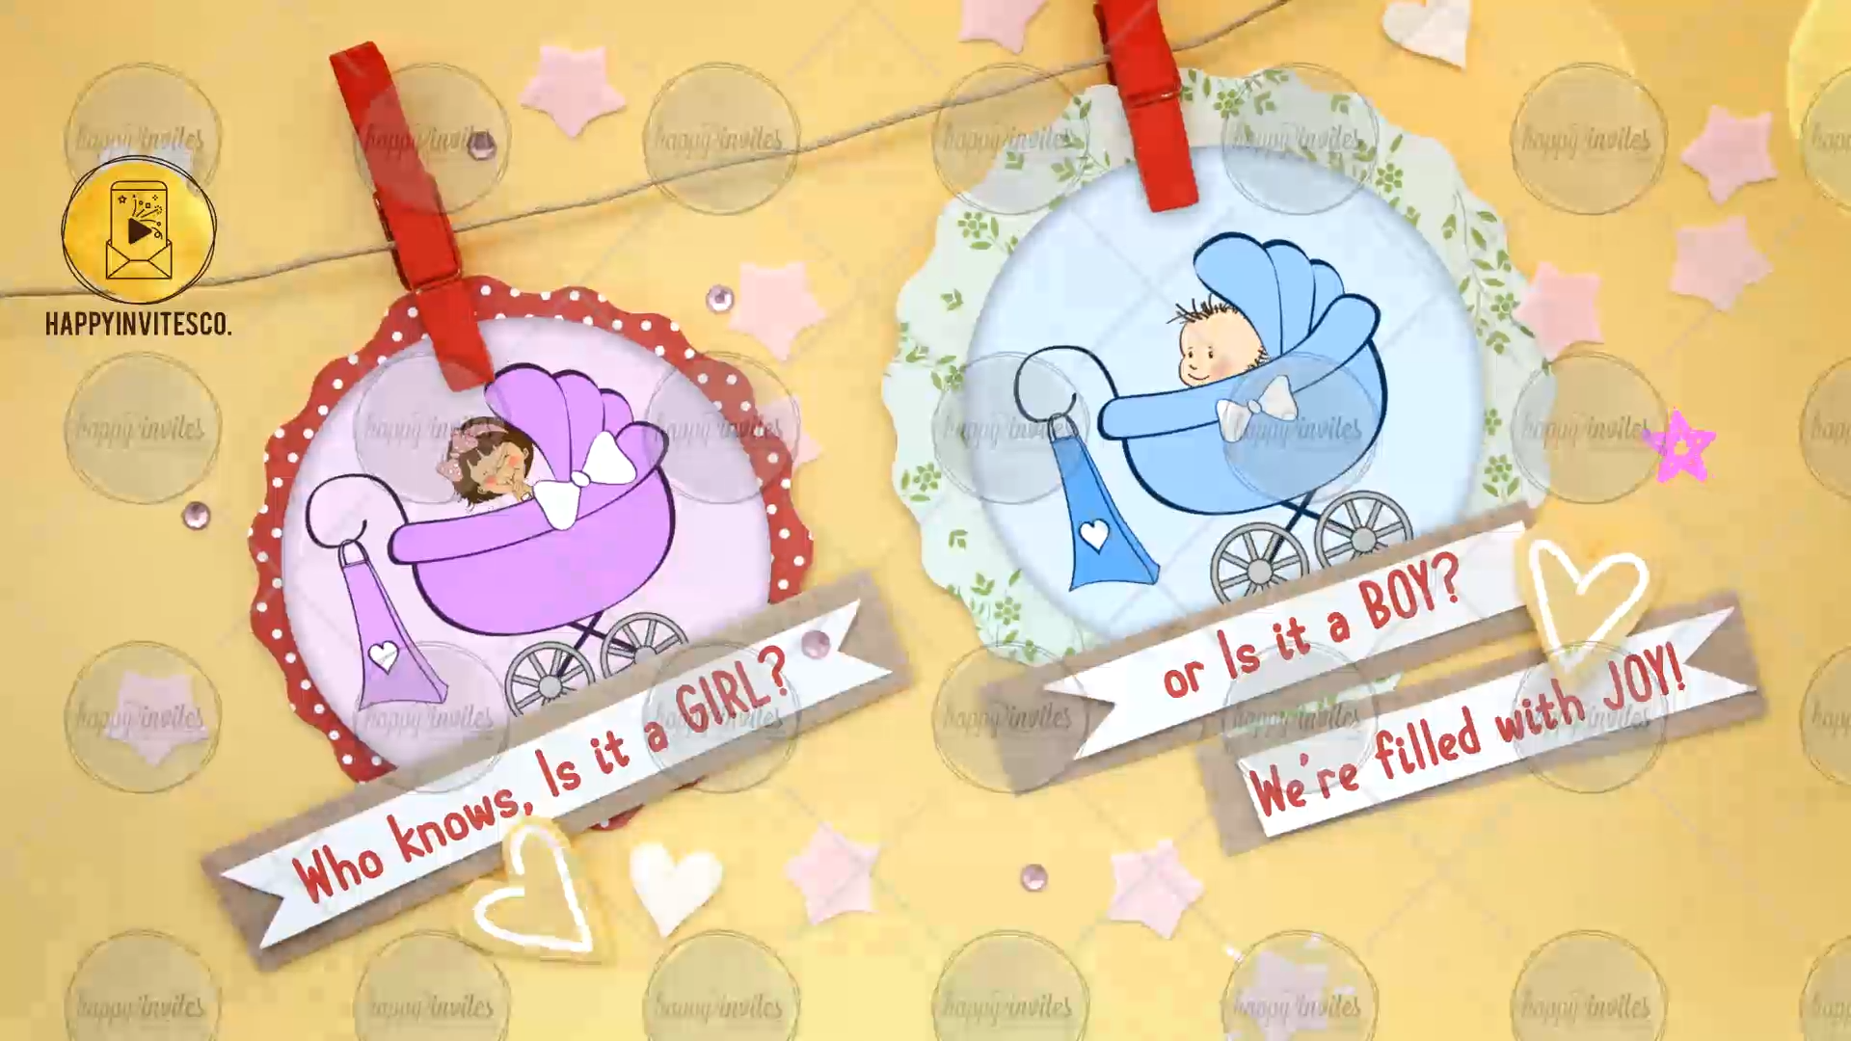
SLIDE 2:
Line 1: Who knows, Is it a GIRL?
Line 2: or Is it s BOY?
Line 3: We’ re filled with JOY!

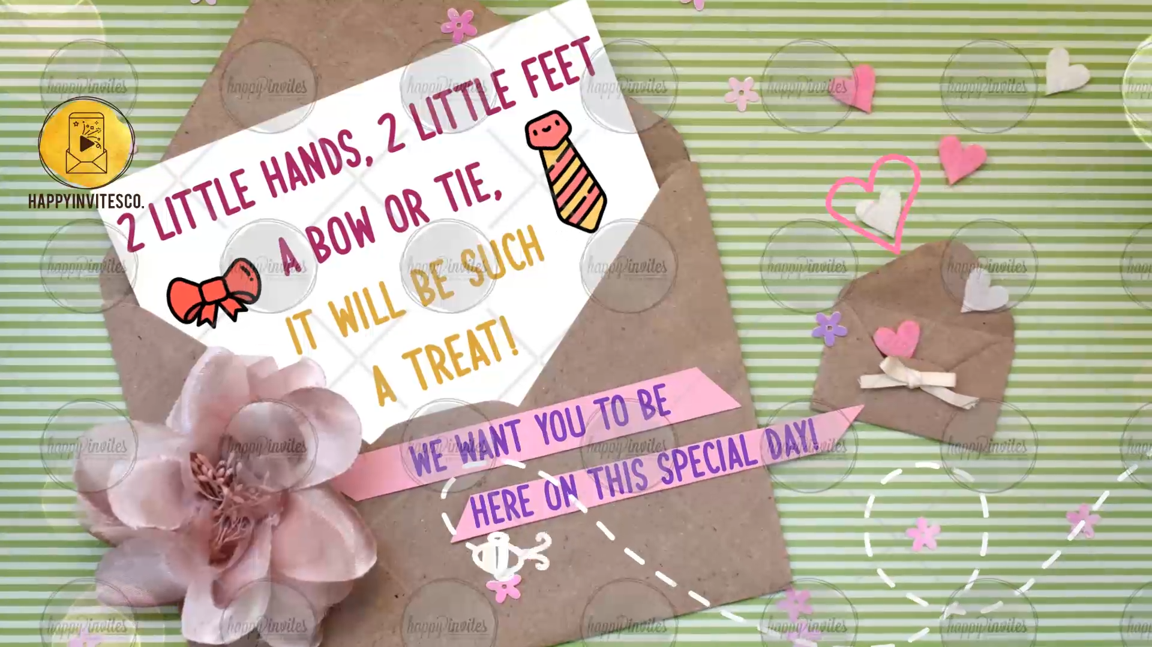
SLIDE 3:
Line 1: 2 Little Hands, 2 Little feet
A bow or tie,
It will be such
A Treat!

Line 2: We want you to be
Here on this special day!

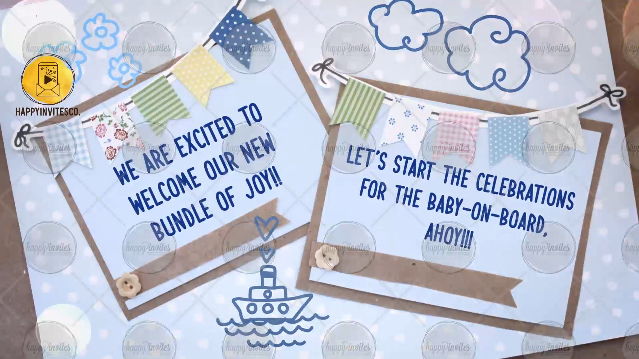
SLIDE 4:
Line 1: We are excited to welcome our new bundle of joy!!
Line 2: Let’s start the celebrations for the Baby-on-Board Ahoy!!!

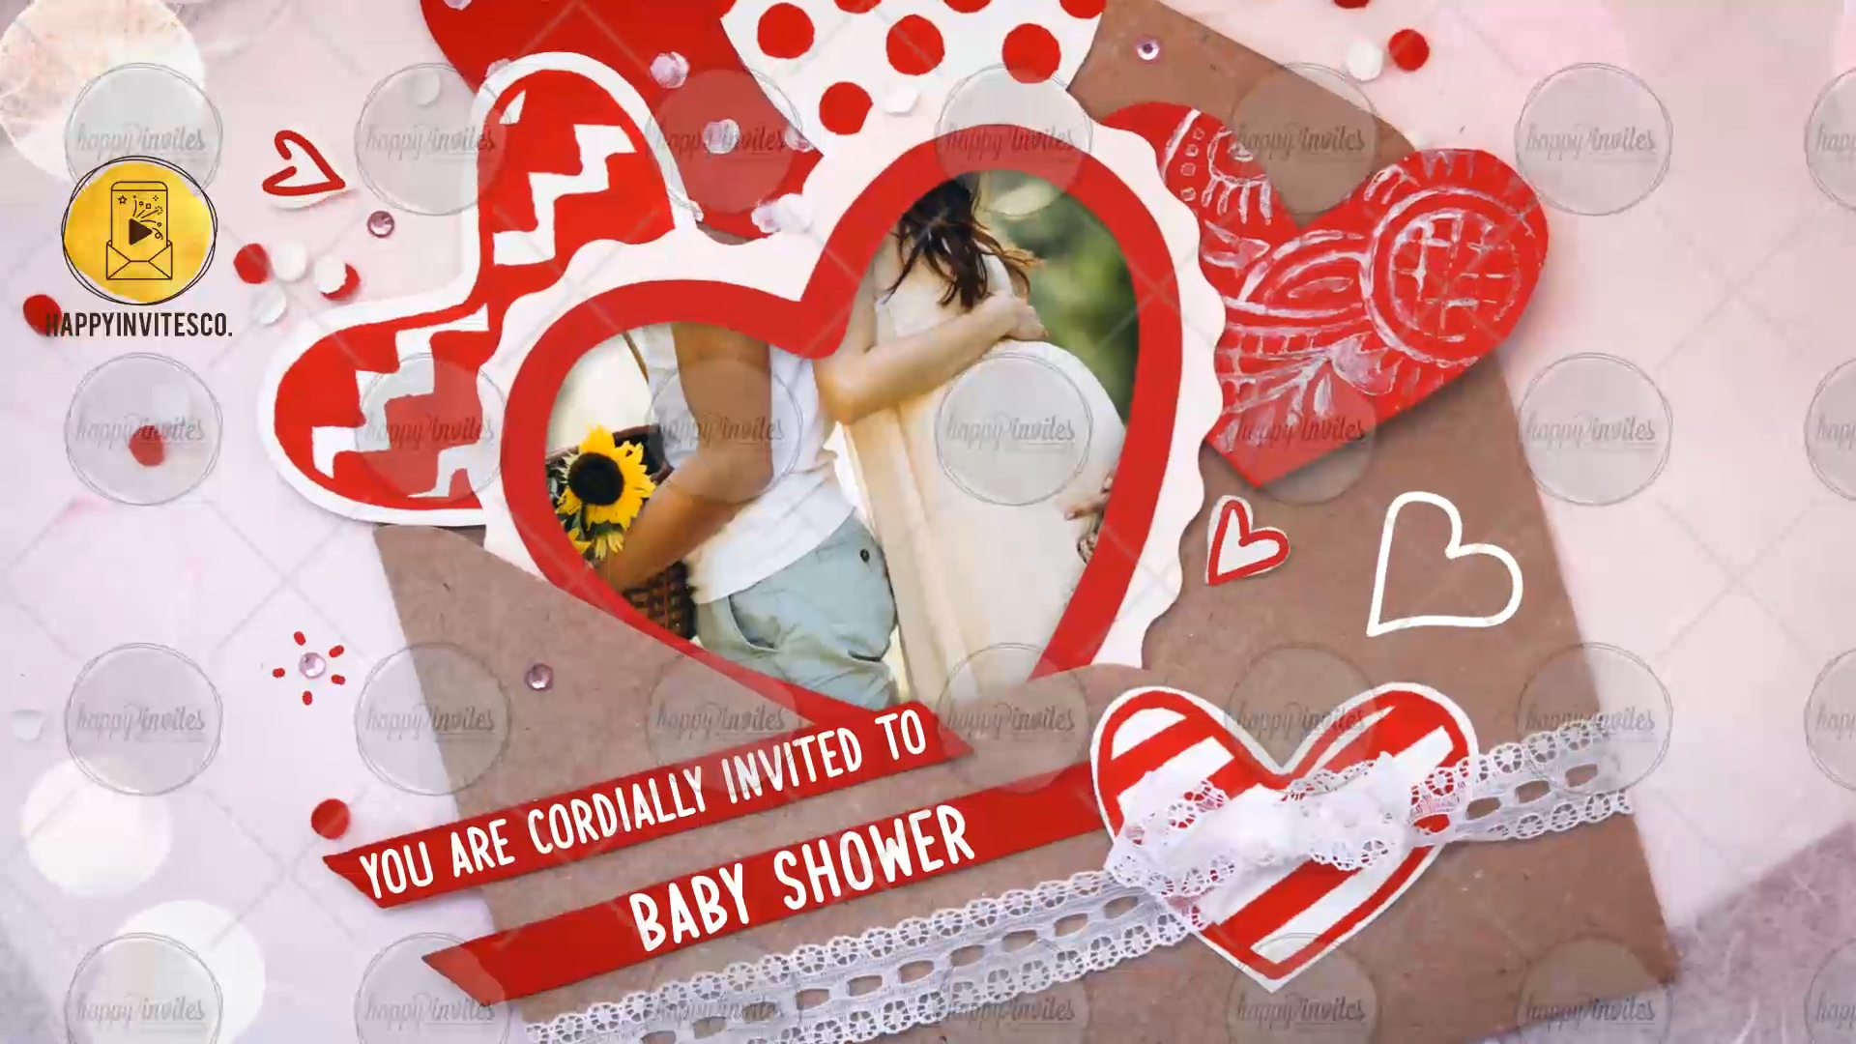
SLIDE 5:
Line 1: You are cordially invite to
Line 2: BABY SHOWER

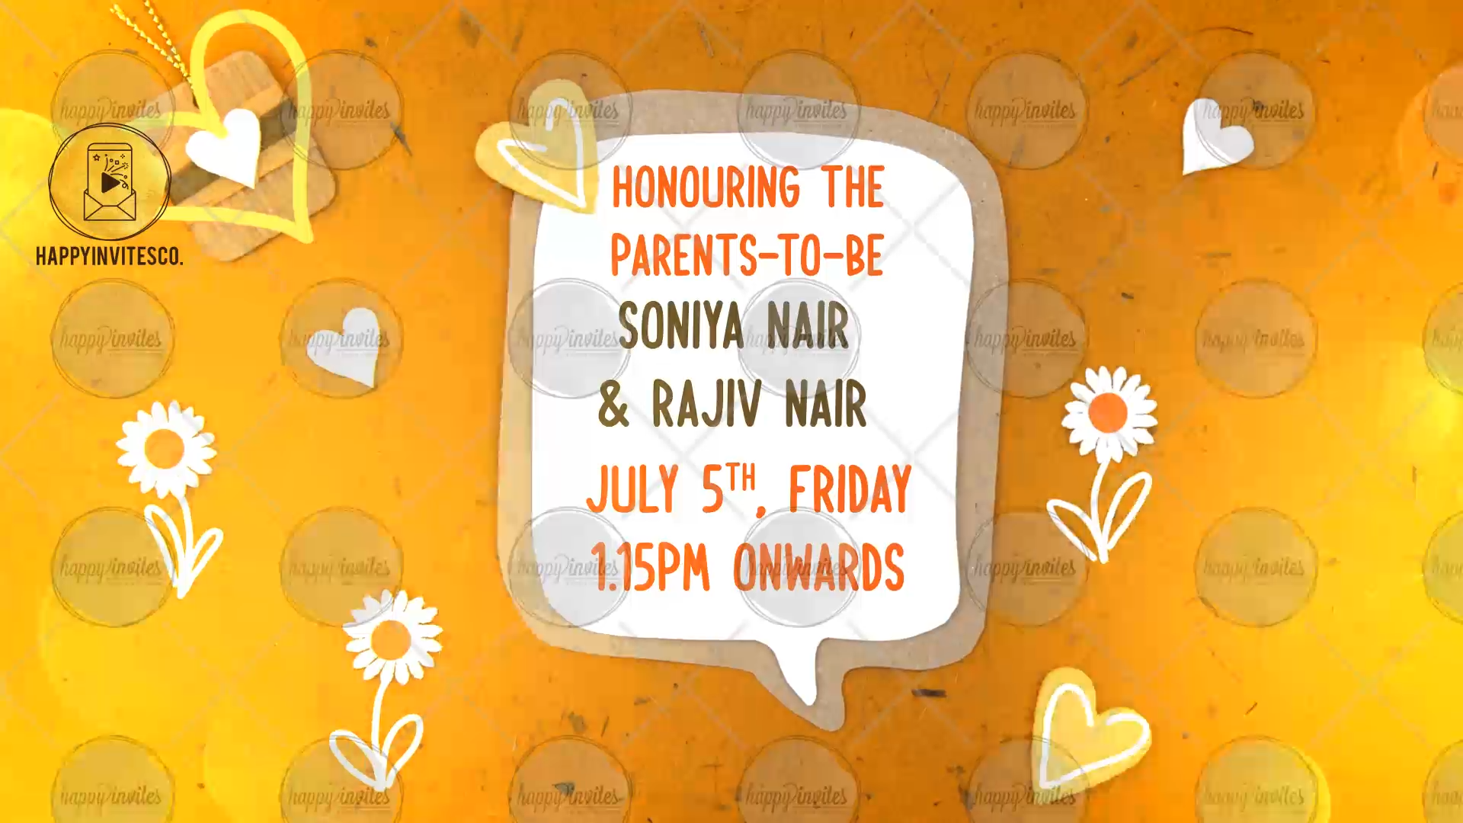
SLIDE 6:
Line 1: Honouring the Parents-to-Be
Line 2: Mention the names of the Parents
Line 3: Date of the function:
Time of the function:

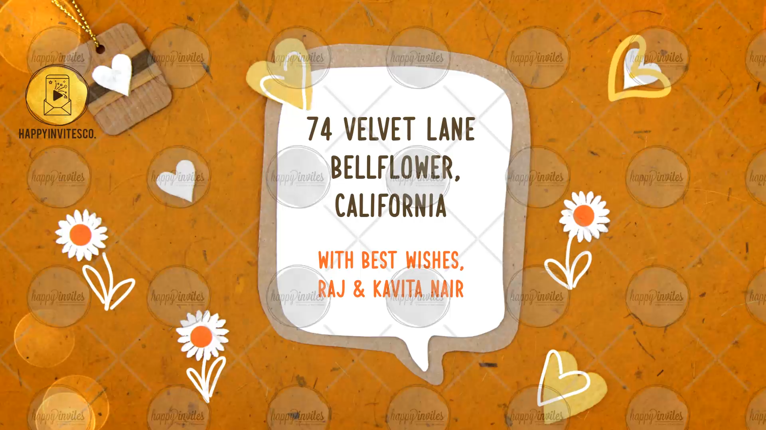
SLIDE 7:
Venue of the Function:
With best wishes,
Please mention the names of family menbers or family surnames

