Email 5 photos on happyinvites.co@gmail.com

SLIDE 1:

Let’s Shower
Love for the

Baby on the way!
-

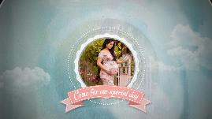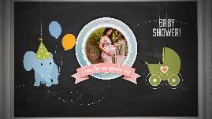
SLIDE 2:

Come for our special day

BABY SHOWER
-

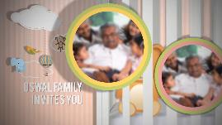
SLIDE 3:

OSWAL FAMILY INVITES YOU
-

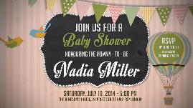
SLIDE 4:

Join us for a
BABY SHOWER
Honouring the Mommy-to-be / Parents-to-be

Name of Mom / Name of Parents

Date
Time
Venue

RSVP Information

