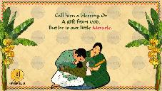
Slide 1:
Call him a blessing or
A gift from God,
But he is our little Miracle.

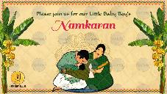
Slide 2:
Please join us for our Little Baby Boy’s
Namkaran

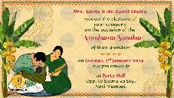
Slide 3:
Name of Parents or Name of Grandparents:
Request the pleasure of
your company
on the occasion of the
Namkaran Sanskar
of their grandson/ granddaughter/ son/ daughter

on Date, Day:
Time

at Venue:

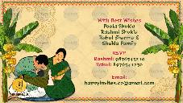
Slide 4:

With best wishes,
Name shere

RSVP

Email:

